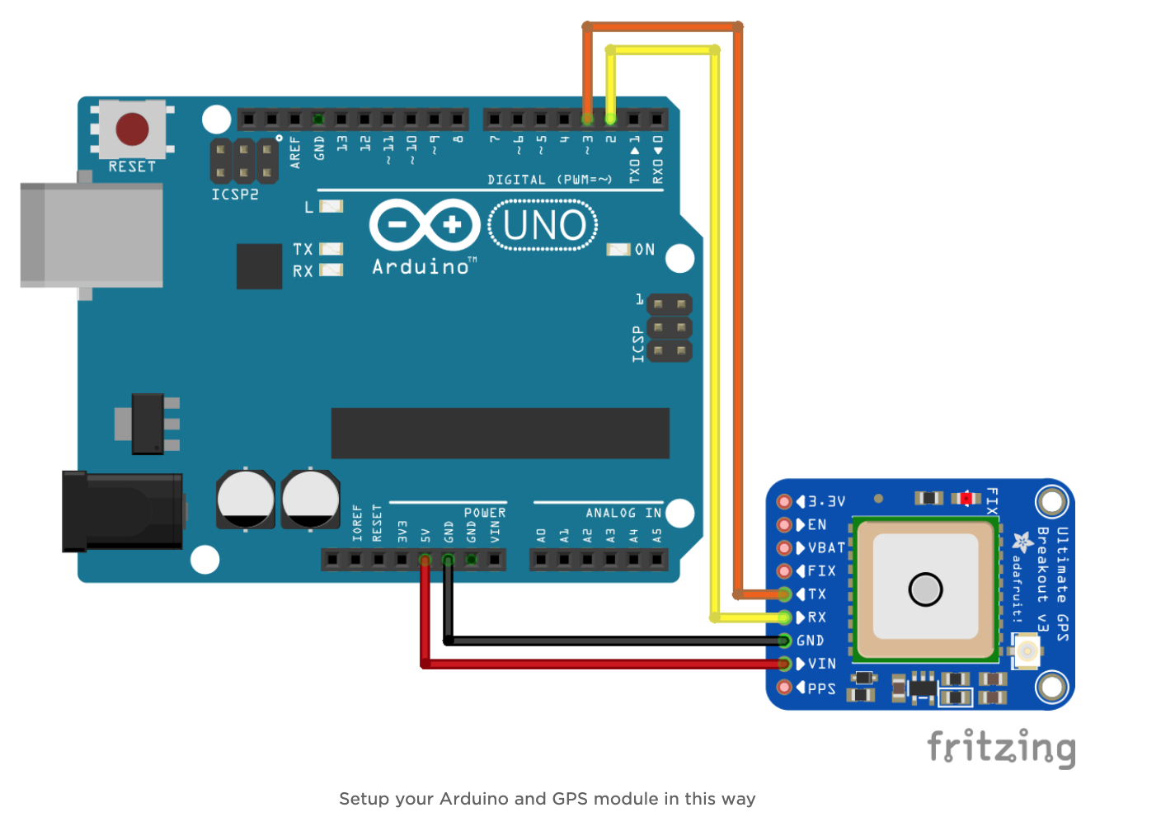

* Connect 5V from the Arduino to Vin on the GPS Breakout
* Connect GND to GND
* Connect the Rx Pin from the GPS Module to Digital Pin 2 on the Arduino
* Connect the Tx Pin from the GPS Module to Digital Pin 3 on the Arduino
* Connect the Arduino to your PC